

*shell programming lab*

aSsignment -14

**SUBMITTED BY: SUBMITTED TO:**

**AYUSH KUMAR JHA Dr. Dhiviya Rose**

**SAP ID - 500086400**

**Enrollment no - R200220083**

**B.C.A -I.O.T.**

**TITLE:**Shell Scripts reading Files

**Activities:**

1.    Write a shell script that takes a command–line argument and reports on whether it is a directory, a file, or something else.

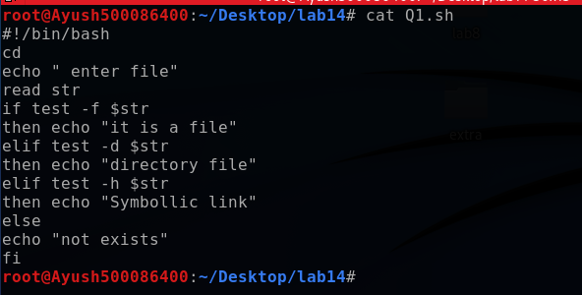

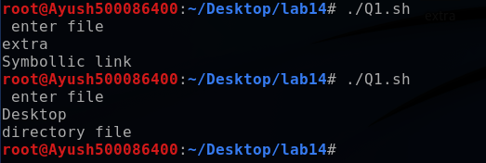

2.    Write a shell program to read a file and find out the total instances of “and” in it.

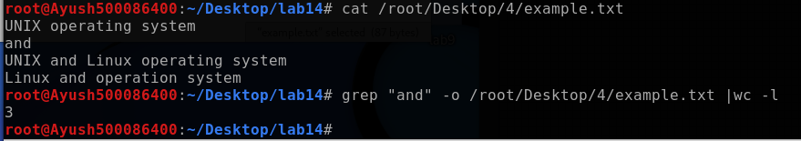

3.    Write a shell script that accepts one or more file name as arguments and converts all of them to uppercase, provided they exist in the current directory.

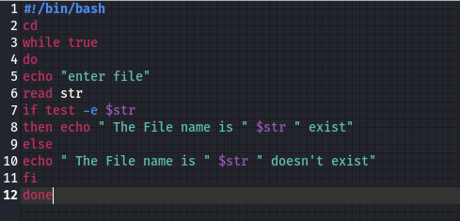

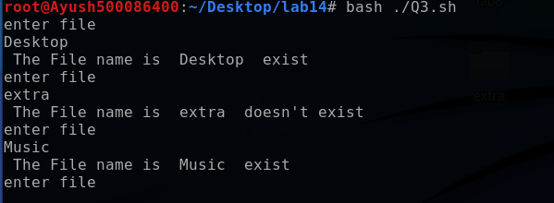

4.    Write a shell script that accepts a file name starting and ending line numbers as arguments and displays all the lines between the given line numbers.

